**Real-time/Field-Based Research Project Report On**

**TasteTrove: A Web-Based Application For Finding Everyday Meals With Taste And Nutrition.**

A dissertation submitted to the Jawaharlal Nehru Technological University, Hyderabad in partial fulfillment of the requirement for the award of a degree of

**BACHELOR OF TECHNOLOGY IN**

**COMPUTER SCIENCE AND ENGINEERING**

Submitted by

**M.Dileep Krishna (23B81A0576)**

**B.Nihan Reddy (23B81A0589)**

**B.Prajeeth Reddy (23B81A0592)**



Department of Computer Science and Engineering

**CVR COLLEGE OF ENGINEERING**

(An UGC Autonomous Institution, Affiliated to JNTUH, Accredited by NBA, and NAAC) Vastunagar, Mangalpalli (V), Ibrahimpatnam (M), Ranga Reddy (Dist.) - 501510,

Telangana State.

**2024-25**

**CVR COLLEGE OF ENGINEERING**

*(*An UGC Autonomous Institution, Affiliated to JNTUH, Accredited by NBA, and NAAC)

Vastunagar, Mangalpalli (V), Ibrahimpatnam (M), Ranga Reddy (Dist.) - 501510, Telangana State.

**DEPARTMENT OF COMPUTER SCIENCE AND ENGINEERING**

**CERTIFICATE**

This is to certify that the project work entitled **TasteTrove-A Web Based Application For Finding Everyday Meals With Taste And Nutrition** is being submitted by DILEEP KRISHNA M(23B81A0576) , NIHAN REDDY B (23B81A0589) and

PRAJEETH REDDY B(23B81A0592) in partial fulfillment of the requirement for the award of the degree of **Bachelor of Technology** in **Computer Science and Engineering,** during the academic year 2024-2025.

**Professor-in-charge RFP Professor and Head, CSE**

**(Dr.M.Swami Das) (Dr. A. Vani Vathsala)**

**DECLARATION**

We hereby declare that this project report titled **TasteTrove-A Web Based Application For Finding Everyday Meals With Taste And Nutrition** submitted to the Department of Computer Science and Engineering, CVR College of Engineering, is a record of original work done by us. The information and data given in the report is authentic to the best of our knowledge. This Real Time/Field-Based Research Project report is not submitted to any other university or institution for the award of any degree or diploma or published at any time before.

DILEEP KRISHNA M**- 23B81A0576** NIHAN REDDY B **- 23B81A0589** PRAJEETH REDDY B **- 23B81A0592**

Date: Place:

**ABSTRACT**

Taste Trove is an intuitive recipe discovery web based application designed to inspire home cooks and food enthusiasts. With a simple yet powerful interface, it leverages advanced search features and personalized recommendations to help users find recipes based on ingredients, meal types, and dietary preferences.Integrated with popular recipe databases, the website provides recipe details, shopping lists, and interactive cooking timers, making it easier than ever to find, cook, and enjoy delicious meals. Whether you're a beginner or an experienced cook, Taste Trove is your ultimate kitchen companion. Find, cook, and fall in love with every meal—Taste Trove makes every kitchen adventure enjoyable!

**Keywords**: powerful interface, advanced search features, popular recipes.

**TABLE OF CONTENTS**

|  |  |  |  |
| --- | --- | --- | --- |
|  | | | Page No. |
|  |  | Abbreviations |  |
|  |  | Symbols |  |
| 1 |  | **INTRODUCTION** | 1 |
|  | 1.1 | Motivation |  |
|  | 1.2 | Problem Statement |  |
|  | 1.3 | Project Objectives |  |
|  | 1.4 | Project Report Organization |  |
| 2 |  | **LITERATURE REVIEW** |  |
|  | 2.1 | Existing Work |  |
|  | 2.2 | Limitations of Existing Work |  |
| 3 |  | **REQUIREMENT ANALYSIS** |  |
|  | 3.1 | Software requirements |  |
|  | 3.2 | Hardware requirements |  |
|  | 3.3 | User requirements |  |
| 4 |  | **SYSTEM DESIGN** |  |
|  | 4.0 | **Proposed System architecture** |  |
|  | 4.1 | Proposed Methods/ Algorithms |  |
|  | 4.2 | Class / Use Case / Activity/ Sequence Diagrams |  |
|  | 4.3 | Datasets and Technology stack |  |
| 5 |  | **IMPLEMENTATION** |  |
|  | 5.1 | Front page Screenshot |  |
|  | 5.2 | Results and Discussions |  |
|  | 5.3 | Testing |  |

|  |  |  |  |
| --- | --- | --- | --- |
|  | 5.4 | Validation |  |
| 6 |  | **CONCLUSIONS** |  |
|  | 6.1 | Conclusion |  |
|  | 6.2 | Future scope |  |
|  |  | **REFERENCES** |  |
|  |  | **APPENDIX: (If any like Published paper / source code)** |  |

**CHAPTER 1**

**INTRODUCTION**

A web-based application is a software solution that operates on web servers and is accessed via web browsers, eliminating the need for local installations. These applications offer cross-platform compatibility, ensuring seamless functionality across various devices and operating systems.

Meals are planned eating occasions that provide essential nutrition and energy. Typically including breakfast, lunch, and dinner, they vary widely across cultures in ingredients and preparation. Beyond nourishment, meals offer opportunities for social interaction and cultural expression, often serving as cherished moments for family and friends to gather and strengthen bonds.

* 1. **MOTIVATION**

In a world where convenience trumps nutritional value, our web-based recipe finder is here to change the face of home cooking. We believe healthy, flavorful meals should be at the heart of every household, and our platform empowers users to make informed , delicious choices in the kitchen. We are here to assist users in managing diets without offending the palates with a user-friendly interface and easy access to comprehensive information on macro-nutrients. Our motto is "Making Home-Made Healthy Food Tasty and Nutritious," a reflection of our purpose in combining wellness with flavor in every-dish.

We understand that meal preparation can be intimidating, whether you’re a seasoned chef or just starting out in the kitchen. That’s why our application is designed with simplicity and ease in mind. Users can quickly search for recipes by name and gain instant access to nutritional information, making it effortless to track and manage macronutrient intake. We hope to create confidence in home cooks by simplifying the process of understanding nutritional content, thus equipping them with the ability to prepare nourishing, enjoyable meals.

Cooking is meant to be a form of creativity, nourishment, and joy and so, our belief in healthy eating forms the core of our platform, committed to making it accessible for all with varied dietary preferences or restrictions. A vast recipe library will include diverse options whether you want to follow a vegan diet, be gluten-free, or want your meal packed with proteins. We would like to make it easy for individuals to adopt healthier lifestyles and provide the tools that they need to cook meals based on personal health objectives.

Our recipe finder is a perfect example of how technology can enhance our daily lives by supporting healthier living. By merging culinary expertise with nutritional science, we’ve created a platform that encourages users to take control of their health while enjoying the process of cooking. The aim here is to bring home cooking back into every single household globally with an approach where flavors are prioritized but not at the cost of nutritional benefits. Using our app, we vision that the celebration of a good meal become synonymous with not only being good tasting but also doing one's body some good.

* 1. **PROBLEM STATEMENT**

This  is  prevalent , as though increased  awareness about the need for  healthy eating exists, many people are still unable to prepare healthy home cooked meals. Mainly, lack of Knowle-dge on nutrition, not having the time, and belief that healthy food does not taste or is hard to prepare will make most people  give in to convenient but nutrient poor alternative. Increased dependence on such unhealthy convenience foods lacking much Nutritional value further perp -etuates the cause of failures in achieving balanced diets.

There is a pressing need for a solution that simplifies the process of discovering and preparing nutritious meals while also educating users about their macronutrient content. Our web-based application directly addresses this gap by providing an easy-to-use platform that helps users find recipes tailored to their dietary needs. By combining convenience with nutritional educa-tion we empower individuals to make healthier choices in the kitchen, fostering a more informed and health-conscious approach to cooking.

**1.3 PROJECT OBJECTIVES**

Our platform encourages healthy eating, providing balanced recipes for use with fresh ingre-dients, along with macronutrient detail, allowing the user to make an Informed decision in terms of preparation. We simplify meal preparation to save precious time for the consumer as they prepare yummy and nutritious meals at home. Our vast reservoir of recipes caters to an incredible variety of tastes, dietary needs, and cultural preferences.

**1.3.1 Promote Healthy and Nutritious Eating:**

Each  recipe on the website must be designed in a way that supports a balanced, nutrient-rich diet, prioritizing natural, fresh ingredients for better overall wellbeing.

**1.3.2 Provide Comprehensive Nutritional Data:**

Provide  macronutrient data  for each recipe to enable users to make informed selections about their personal health goals and dietary requirements.  
  
**1.3.3 Intuitive and Efficient Recipe Search:**

It should have an intuitive, quick search function that allows users to locate recipes by name, ingredients, or dietary preferences for one-click access.

**1.3.4 Save Time during Meal Preparation:**

Optimize the meal planning and cooking process to save time. Their optimized ingredient quantities and resting times will make healthier,  tastier meals easier and quicker to prepare at home without giving in to quality.  
  
**1.3.5 Offer a Diverse Recipe Collection:**

Curate an extensive variety of recipes that cater to different tastes, dietary restrictions, and cultural preferences, providing users with a broad spectrum of options to suit any need.

**1.4 PROJECT REPORT ORGANIZATION**

Chapter 1: introduces the motivation, problem statement, objectives, and organization of the report.

Chapter 2: covers the literature survey, including existing work and the limitations of current Recipe managers.

Chapter 3: describes the software and hardware specifications required for the proposed system.

Chapter 4: outlines the system design and architecture.

**CHAPTER 2**

**Literature Survey**

**2.1 Existing work**

**2.1.1 CookBook**

It is a web app which is also available for android and IOS. It has a user-friendly interface. Allows the users to import recipes from web and they can also scan physical recipes. It is helpful for meal planning and provides smart shopping list for every recipe. It also has multi-device support.

**2.1.2 MealBoard**

Mealboard is an app that simplifies meal planning, grocery shopping, and recipe organization. Users can create meal plans, generate shopping lists, and store their favorite recipes in one convenient place.

**2.1.3 Tandoor**

While not a traditional recipe manager, a tandoor is a versatile used in Indian and Middle Eastern cooking. It provides a unique way to cook various dishes, including tandoori chicken, naan, and kebabs, enhancing the flavors with its high heat and distinctive cooking style.

**2.1.4 BigOven**

BigOven is an app that helps users organize their recipes, plan meals, and generate grocery lists. It also offers a social aspect, allowing users to share their culinary creations and discover new recipes from the community.

**2.1.5 ChefTap**

Chef Tap is a user-friendly app that helps users organize their recipes, create meal plans, and generate shopping lists. It allows users to clip recipes from the web and sync their collection across multiple devices for easy access.

**2.1.6 Paprika Recipe Manager**

Paprika stands out with its ability to save recipes from various websites, create shopping lists, and plan meals. It also offers unique features such as scaling ingredients according to serving size and creating customized grocery lists.

**2.2 Limitations**

**2.2.1 CookBook**

Some features require a paid subscription. Limited number of free features.

**2.2.2 MealBoard**

Requires a one-time purchase for the app. The interface may take some time to get used to.

**2.2.3 Tandoor**

Require self-hosting, which might be a barrier for non-technical users. Some users find the interface less intuitive compared to other tools.

**2.2.4 BigOven**

Free version has ads that can be intrusive. Some features are only available with a Pro subscription.

**2.2.5 ChefTap**

Requires a subscription for full feature access. Occasional syncing issues reported by users.

**2.2.6 Paprika**

Requires separate purchases for different platforms. Only available as a paid app.

**2.3** **PROPOSED WORK**

Our project stands out by eliminating the need for logins, offering seamless user experience on a website. With a simple and straightforward UI, users can effortlessly navigate through the site. Our user-friendly design ensures that everyone, regardless of tech-savviness, can enjoy the full benefits of “TasteTrove”. The advanced search capabilities provide quick and accurate results, making it easy to find recipes based on ingredients. By providing all details in one place, users no longer need to switch between multiple sources. Whether you’re a novice cook or a seasoned chef, our platform caters to all skill levels. The intuitive interface and personalized recommendations enhance the cooking experience. Healthy eating is now accessible and enjoyable for everyone, thanks to our comprehensive and user-friendly website.

**CHAPTER 3**

**SOFTWARE REQUIREMENTS**

**3.1.1 Functional Requirements**

**Recipe Search and Discovery**

**Basic Flow:** Users enter search keywords in the search bar. The system filters recipes based on the keywords. The system displays a list of matching recipes.

**Alternate Flow:** If no recipes match the search criteria, the system displays a message: “No matching recipes found.”

**Recipe Details and Instructions**

**Basic Flow:** Users select a recipe from the search results. The system displays detailed recipe information, including ingredients, instructions, cooking time, and nutritional facts. Users can follow the step-by-step cooking instructions with interactive timers.

**Alternate Flow:** If any required recipe information is missing, the system displays a message indicating that the information is incomplete.

**3.1.2 Non-Functional Requirements**

**Uptime and Availability**

The system should aim to be available most of the time (high uptime) so users can access it whenever they need to.

**Compatibility Requirements**

The application should work on standard web browsers like Chrome, Firefox, and Safari.

**Usability Requirements**

The application should be easy to use with a straightforward interface.

**Scalability Requirements**

The system should be able to handle more users and recipes as needed without slowing down. This ensures the project can grow over time.

**Performance Requirements**

The application should ensure that the page’s load quickly and search results are displayed without delay to provide a smooth user experience.

**Reliability**

The system should be reliable, ensuring consistent operation under various conditions.

**3.2 HARDWARE REQUIREMENTS**

The following hardware specifications are recommended for the Taste Trove recipe manager website to function optimally:

**System Requirements**

• Processor: Minimum 2 GHz dual-core processor to support the client-side

application (e.g., web browser) effectively.

• RAM: At least 4 GB to ensure smooth browsing and voting experience.

• Storage: 128 GB storage capacity for basic software and OS requirements.

• Network: Stable internet connection with at least 5 Mbps download/upload speed

for reliable connectivity.

**CHAPTER 4**

**PROPOSED SYSTEM DESIGN**

**4.0 Proposed System architecture**

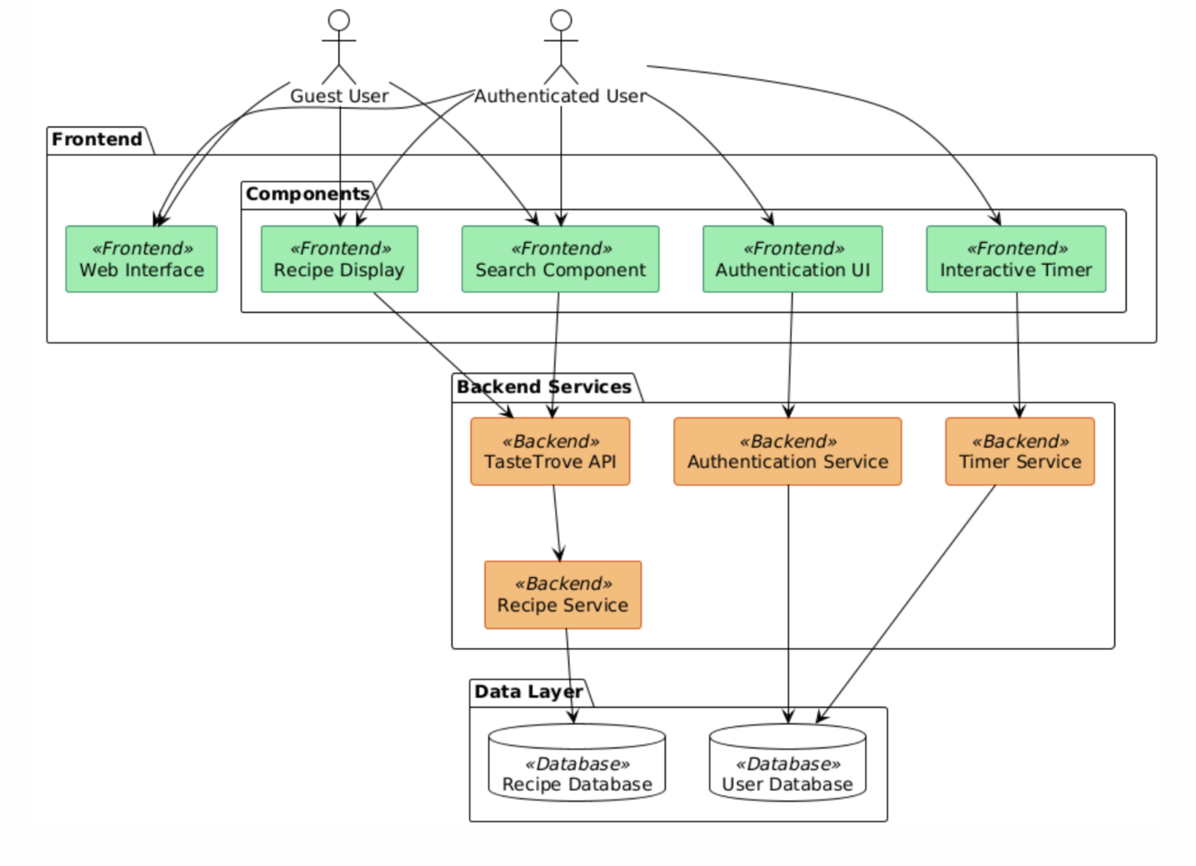

**4.1Proposed Website Workflow for Recipe Manager**

**4.1.1. User Interaction (Landing Page):**

* Users first land on the homepage of the website. The landing page displays options for both log-in and guest users.

**4.1.2. User Authentication:**

* If the user is logged in, the website will show additional features such as interactive timer.
* If the user is not logged in, they can browse the site as a guest with limited features. They can view recipes but will not be able interact with certain advanced features like the interactive timer.

**4.1.3. Recipe Browsing and Searching:**

* Allow users to browse through a collection of recipes.
* Provide a search bar where users can search for specific recipes based on name or ingredients.
* Allow users to filter recipes by dietary preferences (e.g., vegetarian or non-vegetarian). This could be a dropdown or checkbox filter.
* Once the user finds a recipe they are interested in, they can select it to view its details.
* Display detailed information about the recipe including:
  + Ingredients required
  + Cooking steps
  + Nutritional information (if available)

**4.1.4. Interactive Timer (For Logged-in Users):**

* If the user is logged in, they can start an interactive timer that will guide them through the recipe, helping them keep track of cooking time for different stages. The timer should be interactive with the ability to pause, reset, or skip time.

**4.1.5. End the Process:**

* Once the user is done browsing, viewing recipes, or using the interactive timer, the process ends**.**

**4.2.1 CLASS DIAGRAM**

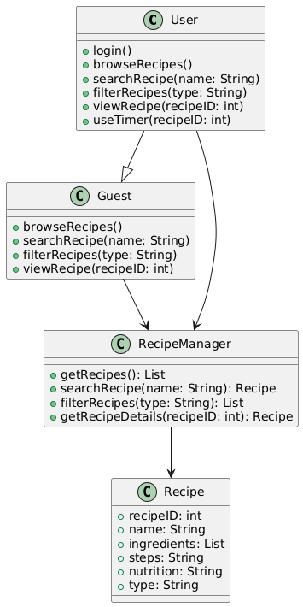

**4.2.2 USE CASE DIAGRAM**

**4.2.3 ACTIVITY DIAGRAM**

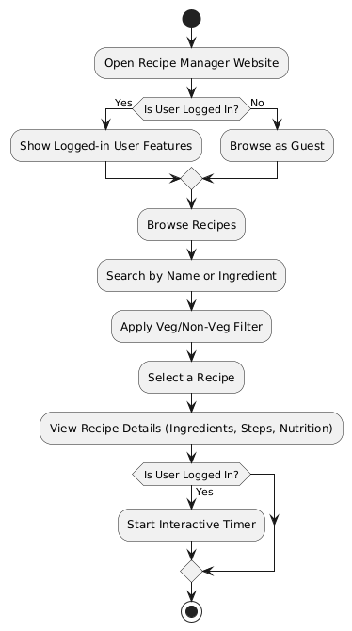

**4.2.4 SEQUENCE DIAGRAM**

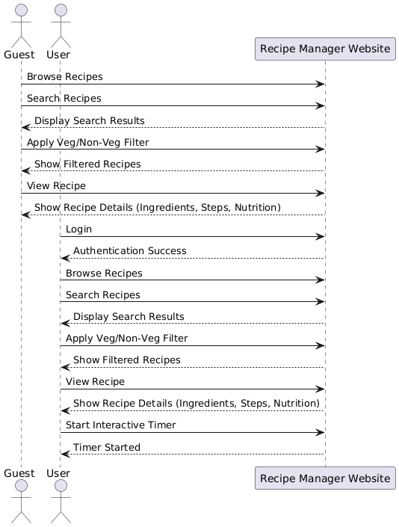

**4.3 Datasets and Technology Stack:**

1. **HTML** - The structural markup language that defines the content and organization of web pages using tags.
2. **CSS** - The styling language that controls how HTML elements look and are presented on screen.
3. **JavaScript** - A programming language that adds interactivity and dynamic behavior to websites.
4. **VS Code** - A free, feature-rich code editor that provides tools for writing, debugging and managing code efficiently**.**